## Supplemental Materials

Narrowed gene functions and enhanced transposon activity are associated with high tolerance to ocean acidification in a juvenile subarctic crustacean

Laura H Spencer1, William Christopher Long1, Ingrid B Spies1, Krista M Nichols2, Robert J Foy1

1 NOAA Fisheries, Alaska Fisheries Science Center, 7600 Sand Point Way NE, Seattle, WA 98115, USA

2 Northwest Fisheries Science Center, National Marine Fisheries Service, National Oceanic and Atmospheric Administration, 2725 Montlake Blvd E, Seattle, WA, 98112, USA

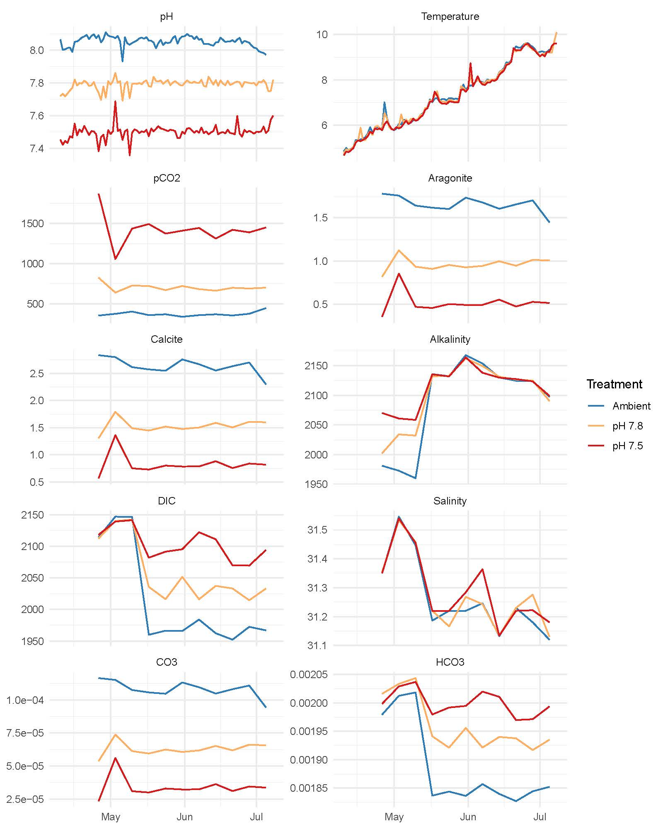

**Supplemental Figure 1:** Water parameters during the experiment. Temperature and pH were measured daily; salinity, dissolved inorganic carbon (DIC) and alkalinity were measured weekly, beginning Week 2; all other parameters were calculated. Lines are mean values across tanks for each treatment.

**Supplemental Table 1**: Mean water parameters for each tank. See separate file or [Supplemental-Table-1_Water-parameters-by-tank.csv](https://github.com/laurahspencer/red-king_RNASeq-2022/blob/main/manuscript/PLOS-Climate-submission/Supporting-Information/Supplemental-Table-1_Water-parameters-by-tank.csv)

**Supplemental Figure 2:** PCA biplot of principal components 3 and 4, constructed from RNA-Seq derived SNPs (n=331). Points represent individual crabs that are color-coded by OA treatment, which do not indicate clustering by treatment, and sizes represent the percent of SNPs that are missing in each individual.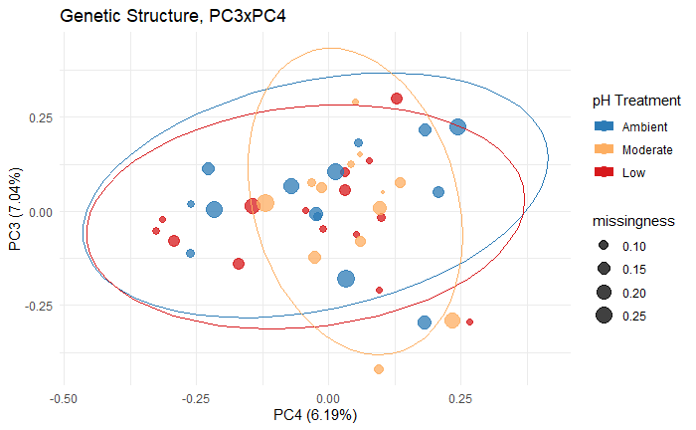

## 

**Supplemental Figure 3**: Correlation plots among SNP-derived PCA scores and gene expression-derived PCA scores along the first two principal components, with Pearson correlation coefficients and p-values calculated for each treatment.

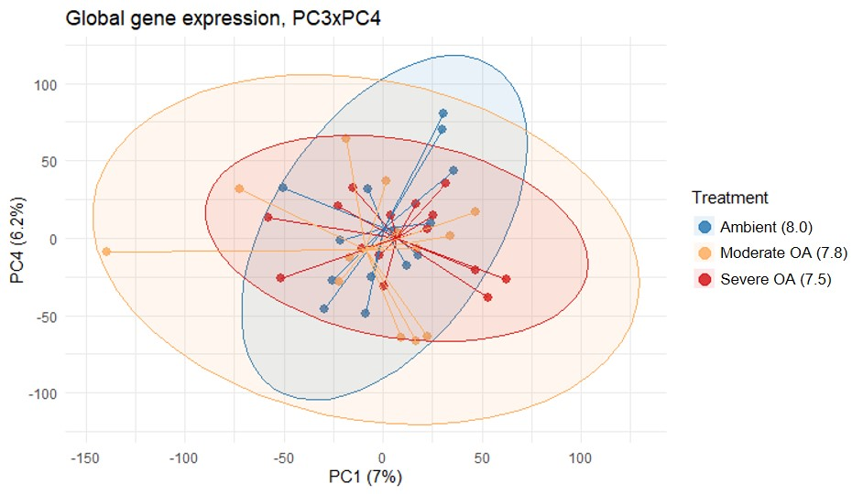

**Supplemental Figure 4.** PCA biplot of principal components 3 and 4 constructed from all expressed genes.

## 

**Supplemental Table 2:** Statistics for modules with eigengenes that correlated significantly with pCO2 concentration. Modules in purple (↓) and green (↑) indicate modules for which gene expression decreased and increased with pCO2, respectively. The percent of genes that were transposable elements are also included for each module. Modules are randomly assigned color names, and the letters correspond to Figure 5 panels in the main text.

|  |  |  |  |  |  |
| --- | --- | --- | --- | --- | --- |
| **Module** | **No. of genes in module** | **No. of genes in module that are also differentially expressed** | **Weighted Pearson correlation with pCO2 (P-value)** | **% Transposable Elements** | **No. of enriched biological process GO terms at EASE<0.05**  **(FDR 10%)** |
| a (magenta) ↓ | 6,602 | 1,280 | -0.52 (4.5e-4) | 45% | 43 (11) |
| b (lightcyan) ↓ | 4,169 | 1,171 | -0.45 (2.9e-3) | 39% | 60 (31) |
| c (firebrick4) ↓ | 1,573 | 191 | -0.39 (9.7e-3) | 60% | 4 (0) |
| d (darkviolet) ↓ | 92 | 17 | -0.37 (0.016) | 23% | 6 (4) |
| e (royalblue) ↓ | 1,245 | 197 | -0.36 (0.019) | 32% | 19 (3) |
| f (coral1) ↓ | 162 | 21 | -0.34 (0.028) | 40% | 5 (0) |
| g (plum1) ↓ | 449 | 40 | -0.31 (0.042) | 53% | 6 (1) |
| h (pink) ↓ | 8,245 | 980 | -0.30 (0.049) | 63% | 50 (15) |
| i (blue2) ↑ | 96 | 16 | 0.36 (0.018) | 92% | 0 |
| j (lightsteelblue1) ↑ | 306 | 20 | 0.42 (5.4e-3) | 53% | 2 (0) |
| k (ivory) ↑ | 301 | 84 | 0.44 (3.4e-3) | 43% | 13 (0) |
| l (lightgreen) ↑ | 7,080 | 515 | 0.45 (2.7e-3) | 76% | 13 (4) |
| m (purple) ↑ | 2,862 | 328 | 0.46 (2.1e-3) | 77% | 7 (4) |
| n (green) ↑ | 8,603 | 1,453 | 0.50 (6.6e-4) | 68% | 13 (2) |

**Supplemental Table 3:** Number of differentially expressed genes and enriched GO terms by pairwise treatment contrast. Colors and arrows indicate the number of DEGs and GO terms that were upregulated (↑) and downregulated (↓) in the more severe OA treatment, where ambient = pH 8.0, moderate = pH 7.8, and severe = pH 7.5.

|  |  |  |  |  |  |
| --- | --- | --- | --- | --- | --- |
| **OA treatment contrast** | No. of DEGs | No. of enriched Biological Processes | No. of enriched Molecular Functions | No. of enriched Cellular Components | % Transposable Elements |
| Ambient vs Moderate | 526 ↑  933 ↓ | 9 ↑  23 ↓ | 7 ↑  18 ↓ | 2 ↑  16 ↓ | 51.4% ↑  30.6% ↓ |
| Ambient vs Severe | 2,350 ↑  3,907 ↓ | 5 ↑  81 ↓ | 10 ↑  47 ↓ | 1 ↑  29 ↓ | 64.5% ↑  27.7% ↓ |
| Moderate vs Severe | 22 ↑  25 ↓ | 3 ↑  2 ↓ | 5 ↑  0 ↓ | 0 ↑  0 ↓ | 85.7% ↑  12.5% ↓ |

**Supplemental Table 4**: See separate file or [Enrichment results from WGCNA modules](https://github.com/laurahspencer/red-king_RNASeq-2022/blob/main/manuscript/Supplemental/Supplemental-Table-3_WGCNA-Enrichment-Results.csv)

**Supplemental Table 5**: See separate file or [Enrichment results from DEG analysis](https://github.com/laurahspencer/red-king_RNASeq-2022/blob/main/manuscript/Supplemental/Supplemental-Table-4_DEG-Enrichment-Results.csv)

**Supplemental Table 6**: See separate file or [Enrichment results from upregulated low-variance genes](https://github.com/laurahspencer/red-king_RNASeq-2022/blob/main/manuscript/Supplemental/Supplemental-Table-5_Upregulated-Low-CV-Enrichment-Results.csv)

**Supplemental Table 7:** See separate file or [Transposable elements detected, list of 68 unique Uniprot IDs](https://github.com/laurahspencer/red-king_RNASeq-2022/blob/main/manuscript/Supplemental/Supplemental-Table-6_Transposons.csv)

**Supplemental Table 8**: Percent of genes differentially expressed among pairwise contrasts that map to transposable elements. Colors indicate genes that were more active in ambient (blue), moderate OA (orange), and severe OA (red) treatments in each pairwise comparison. Values below the dotted line indicate the % of upregulated genes with low within-treatment variation (CV < 3%) that were TEs.

|  |  |  |  |
| --- | --- | --- | --- |
|  | Ambient | Moderate | Severe |
| Ambient |  | 51% | 65% |
| Moderate OA | 31% |  | 86% |
| Severe OA | 28% | 13% |  |
| Upregulated with low variance (CV< 3%) | 16% | 50% | 60% |